Welcome to use Google Calendar for our district 4-C4 calendar

Several Reminders
- Please double check the information showed in calendar is correct as we pre-input some of your club’s events into our district calendar, but you are welcome to edit or delete the events.
- After, you create an event, we recommend you to double check your event to make sure the event is already in our district calendar. Our district calendar website is http://lions4c4.org/event-grid/district-calendar/
- Once you create your event, the event is immediately in our district calendar.
- Contact Tony at tonycph1124@gmail.com if any problem occurs.

Parts Breakdown:
- From invitation email to calendar (P.2)
- invitation email to non-google email (P.2-6)
- invitation email to google email (P.7)
- Edit existing events (P.8-19)
- title (P.8)
- date and time (P.9-10)
- map and location (P.11)
- choose the right calendar (P.12)
- description (P.12-13)
- invite (P.14)
- attachment (P.15 and P.17-19)
- make the event visible to public (P.16)
- Create a new event (P.20)
- Delete an event (P.21)
- Next time you want to return to your calendar (P.22)
- Sharing your club’s calendar to others, so they can edit your complete calendar, not only on just 1 event (P.23-24)

Part I: From invitation email to to Calendar
For Gmail account holder, please go step 12.
Other mail account holder, please follow from step 1.
1. You will receive an invitation email such as below one. Then, click the circled line.
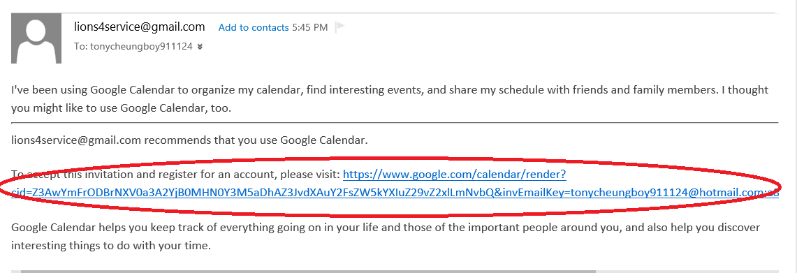
2. Click “Create account”
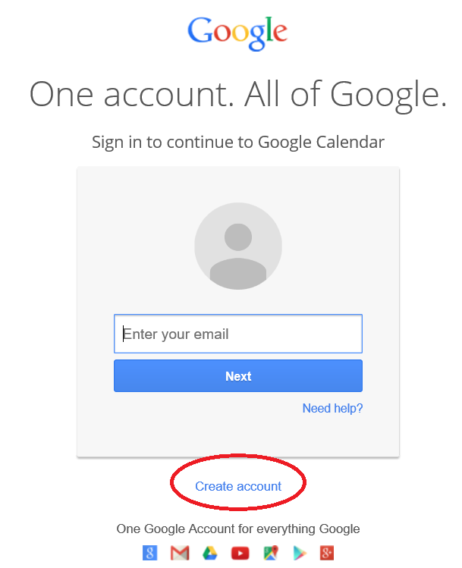

3. If you want to use same email address to register google account, click “I prefer to use my current email address”; otherwise, choose a username for your new Google account. Then, fill in all the information. This registration decide your login account to edit your club’s calendar. Last, click “Next step” at the bottom.
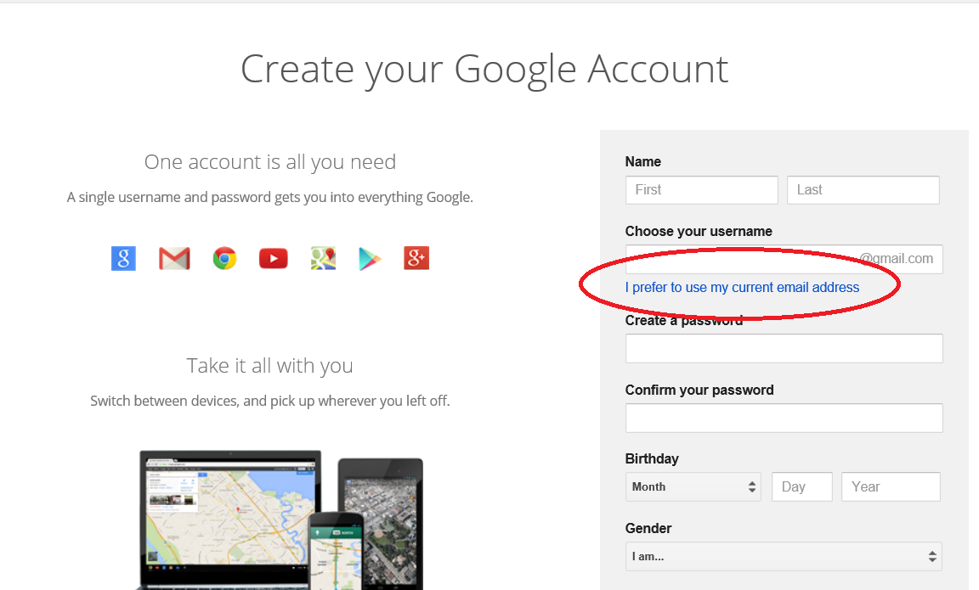
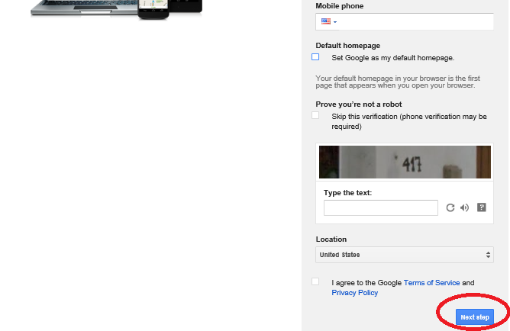

4. Then, click “continue” to verify your account.
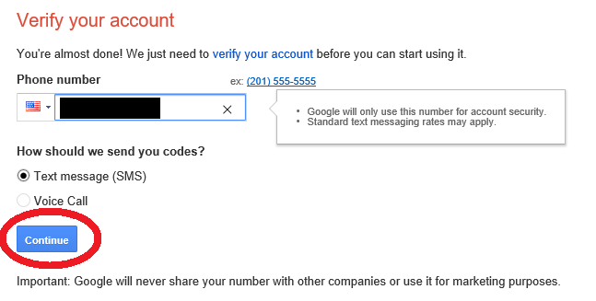
5. You will get a verification code via your selection on last step. Enter the code, then click “continue”.
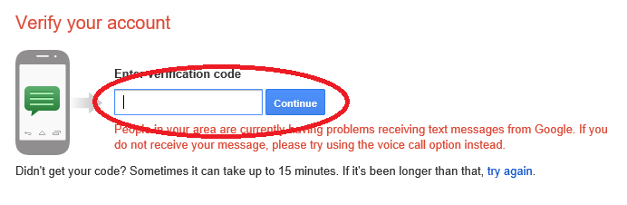
6. Click “Verify now”
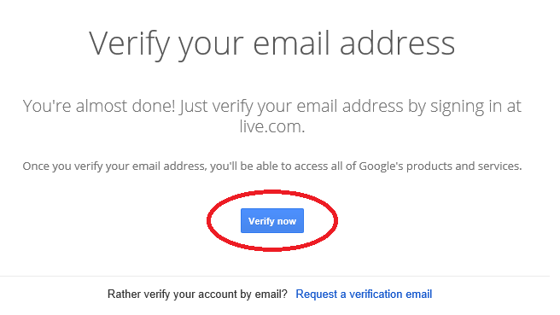
7. Click “Yes” if you accept Google Terms.
If you cannot accept Google Terms, let us know because you cannot use Google Calendar without accept their terms.
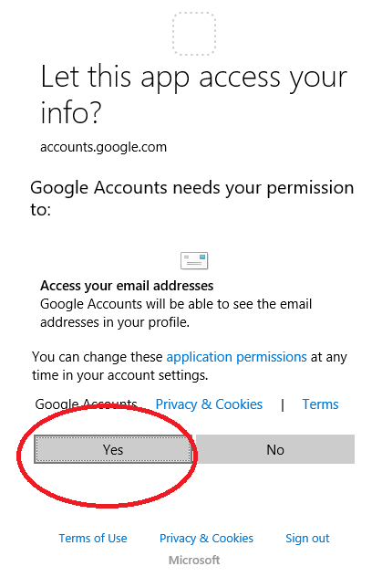
8. You are done with the registration. Click “Back to Google Calendar” or Click the square on the top right side, then click “Calendar”.
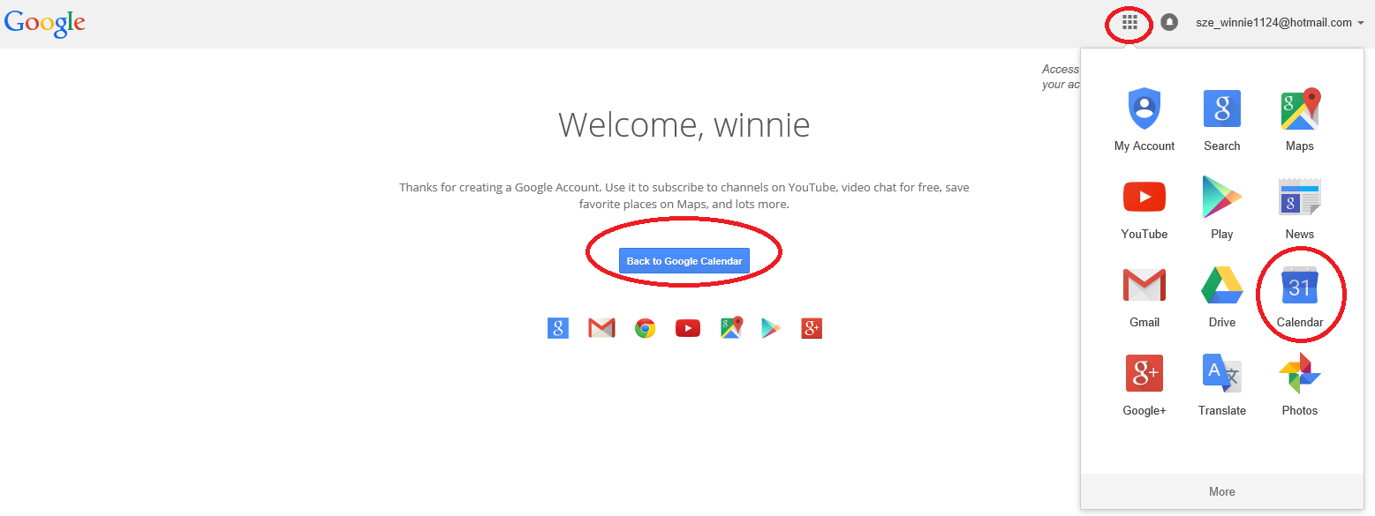

9. Click “Got it”
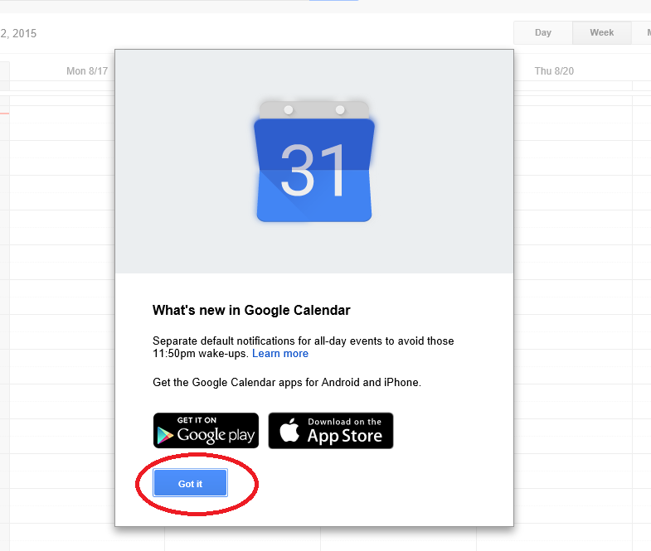
10. Then, go back to the invitation email and click the link again.
11. Click “Yes, add this calendar”
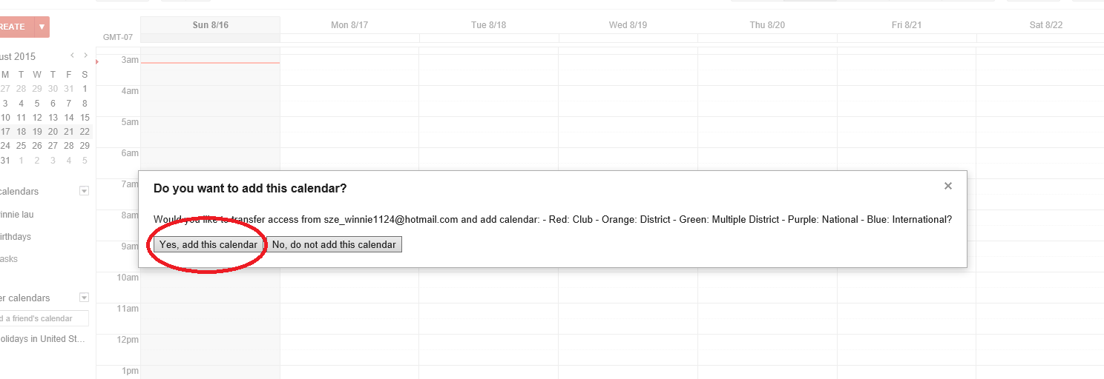
Then, skip step 12.
12. Go to Gmail. You will get an invitation email which is almost same as the below one except the Google Calendar called “……”. Then, click on “View Your Calendar”
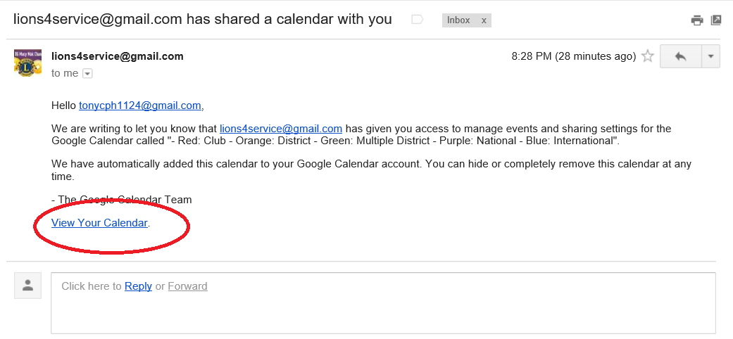
13. Click month on the top right side, which is circled in the below picture.
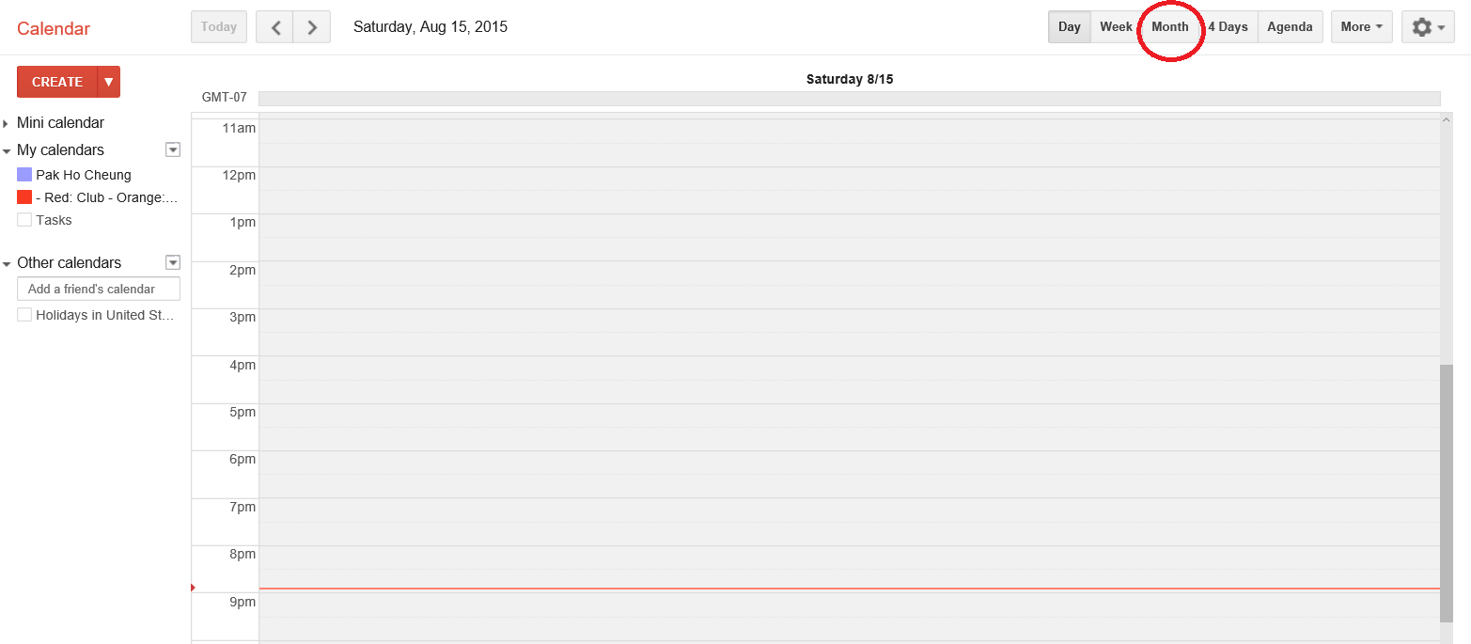
14. You will see some of events are already on your calendars like example events (testing 1 and testing 2) in below picture.
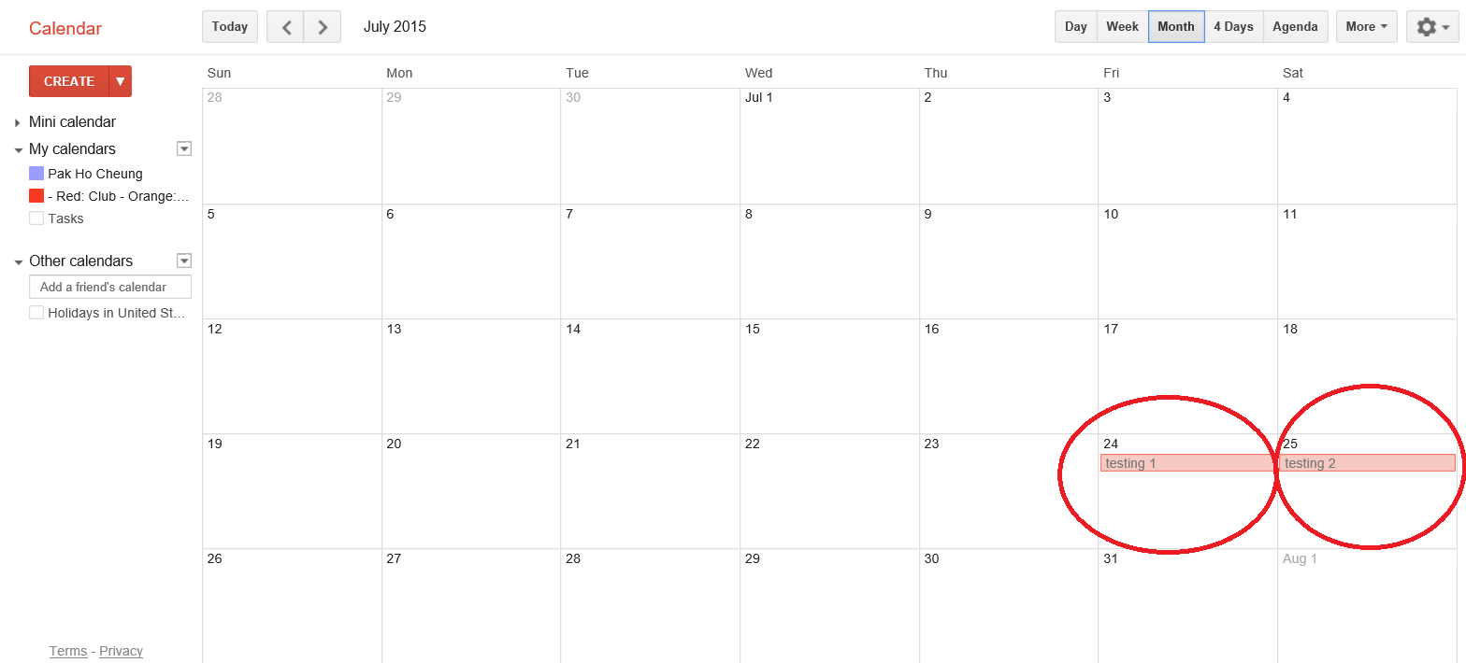

Part II: Edit existing events
1. Click one of events, then click “edit event”
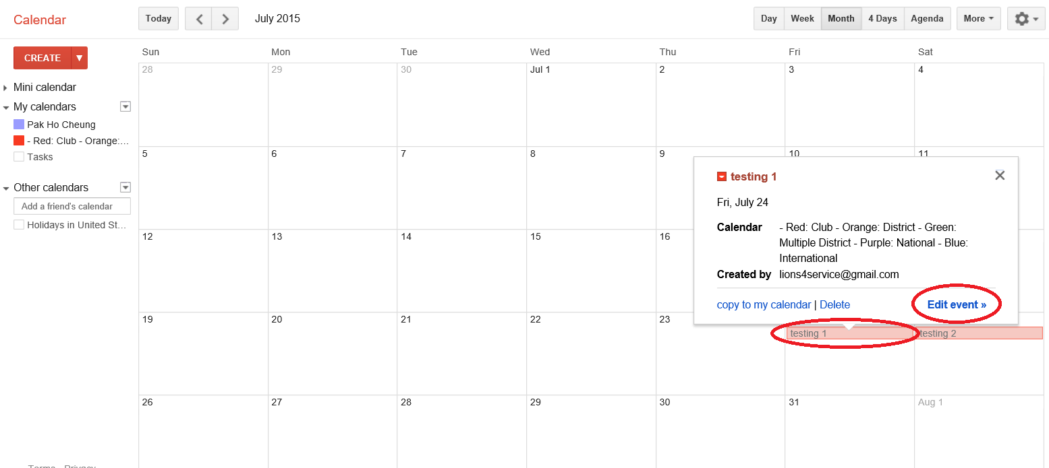
2. To edit the title, click the column as below picture.
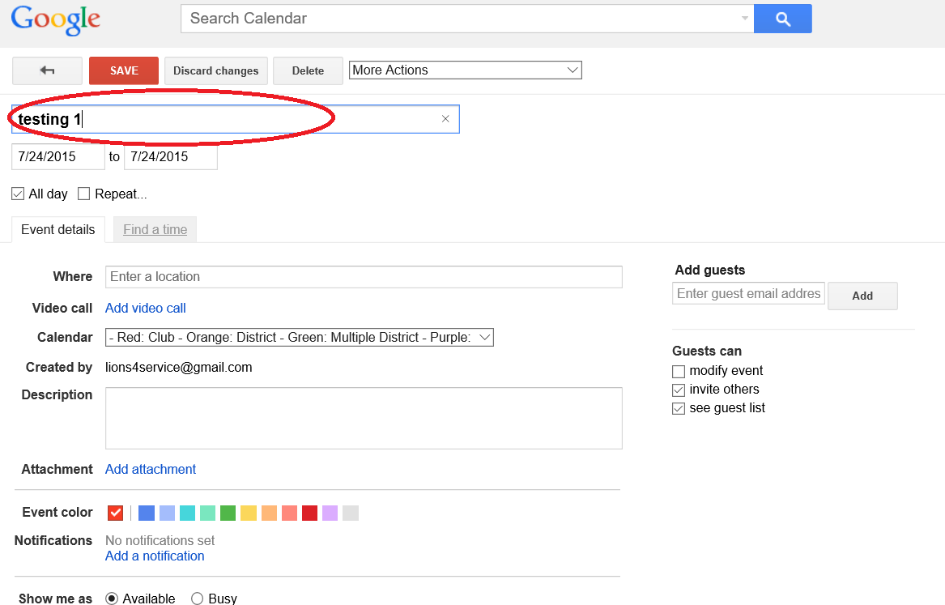

3. To edit the date your club is going to meet, click the column as below picture.
If your event is all day event, click “All day”. Otherwise, unclick “All day”.
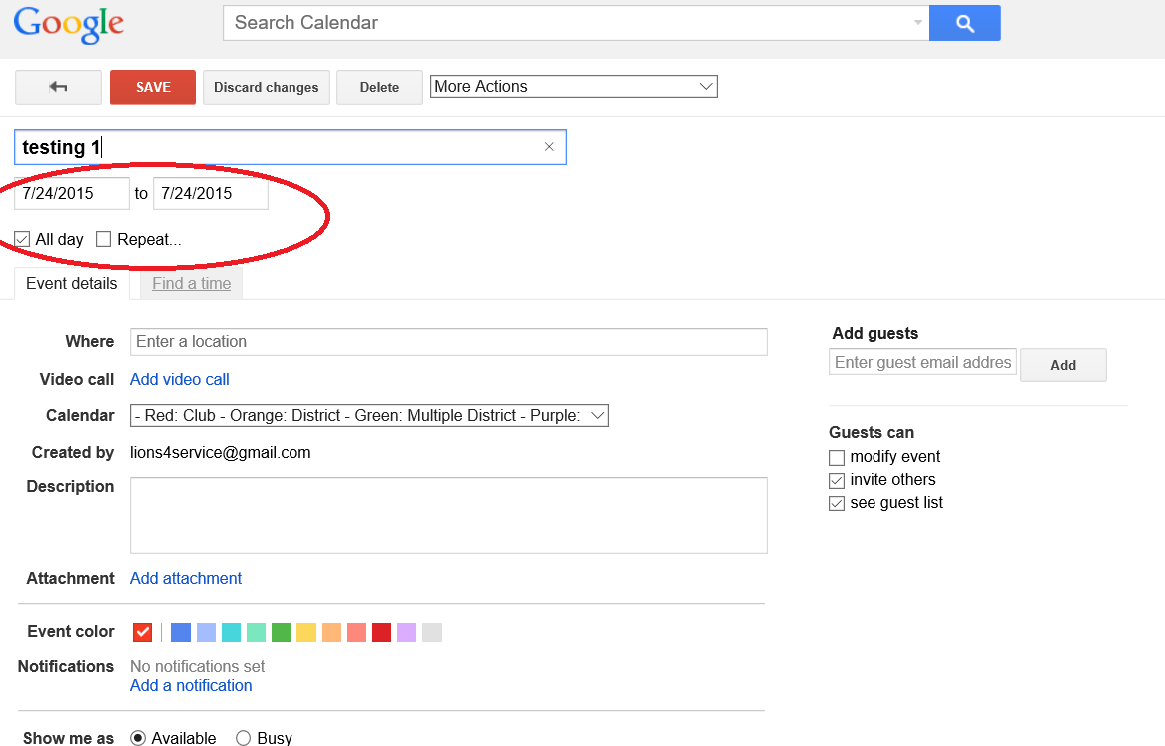
4. If your event is not all day event, you can choose start time and end time.
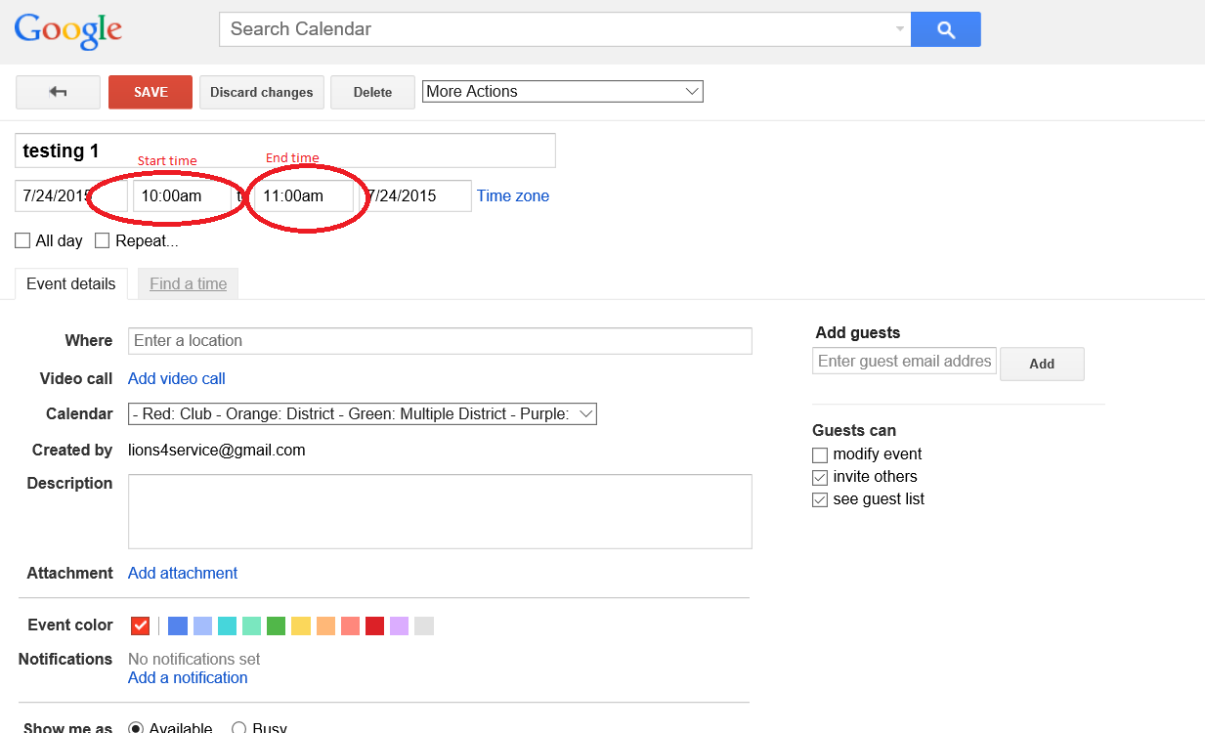

5. If your event is going to repeat weekly, monthly or other, click “Repeat”.
Select your event’s meeting period in “Repeats”, “Repeat every”, “Repeat by” and “Start on”
Last, you can check whether your selections match what you want in “Summary”.
Some examples,
(a.) if your club is meeting on first Monday of each Month, the selections will be
Repeats: Monthly
Repeat every: 1 Months
Repeat on: day of the week
Start on: 7/6/2015 (Just choose one day which is first Monday)
Summary: You will see “Monthly on the first Monday”
(b.) if your club is meeting on first and third Monday, you have to create two events, one for first Monday and one for third Monday.
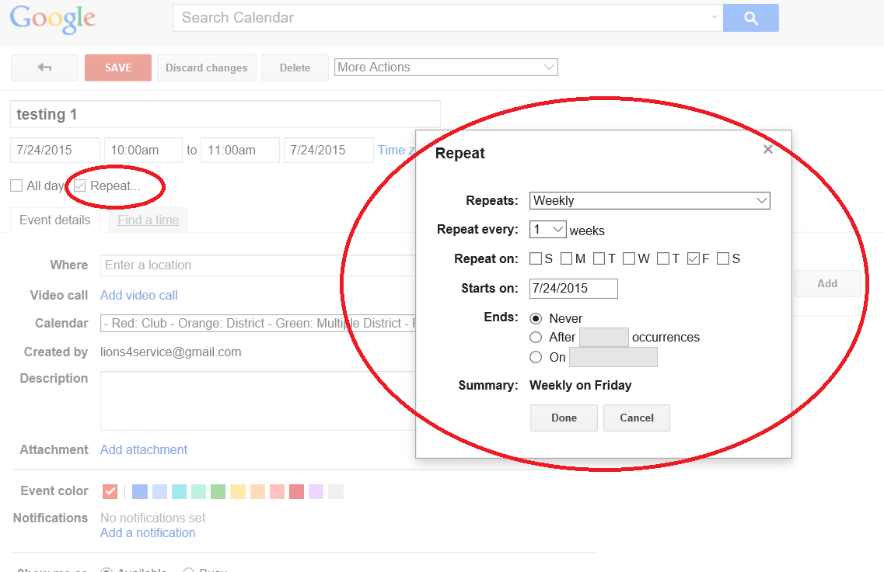

6. If you want to edit the address your club is going to meet, click the column as below picture. Then, the feature of Maps and direction will be on your event.
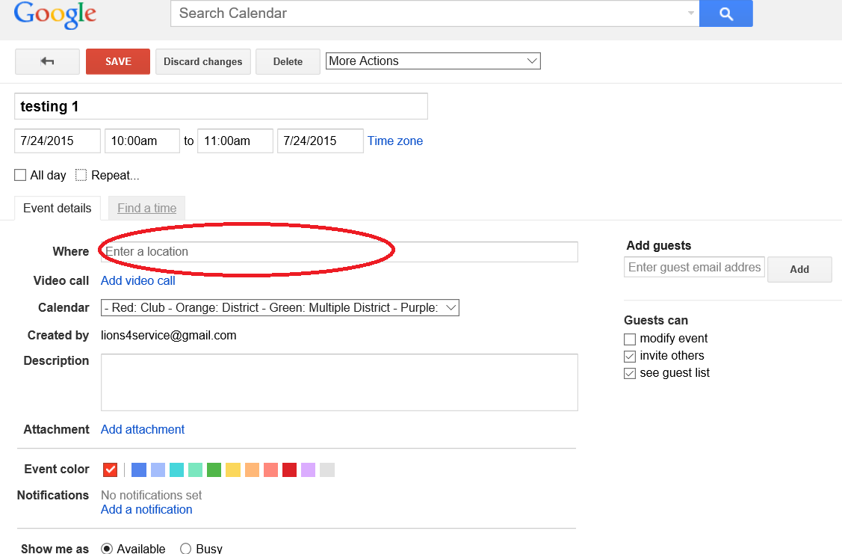

7. We are not recommend Video Call for now, so this instruction will not provide how to use “Add video call”.
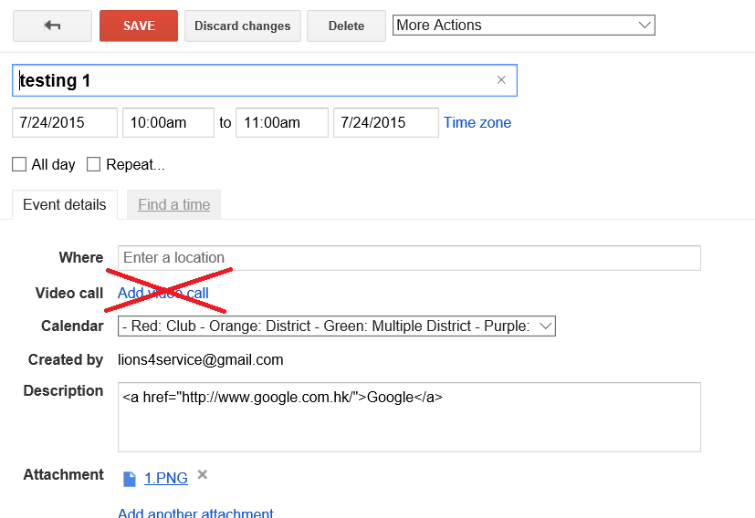
8. For Calendar, please select your club calendar.
For example,
Bay Area Special Olympics Lions Club is named as “BAY AREA SPECIAL OLYMPICS”.
Belmont Lions Club is named as “BELMONT”.
Brisbane Lions Club is named as “BRISBANE”.
Your event will be unable to show in our district calendar if fail to select the right calendar.
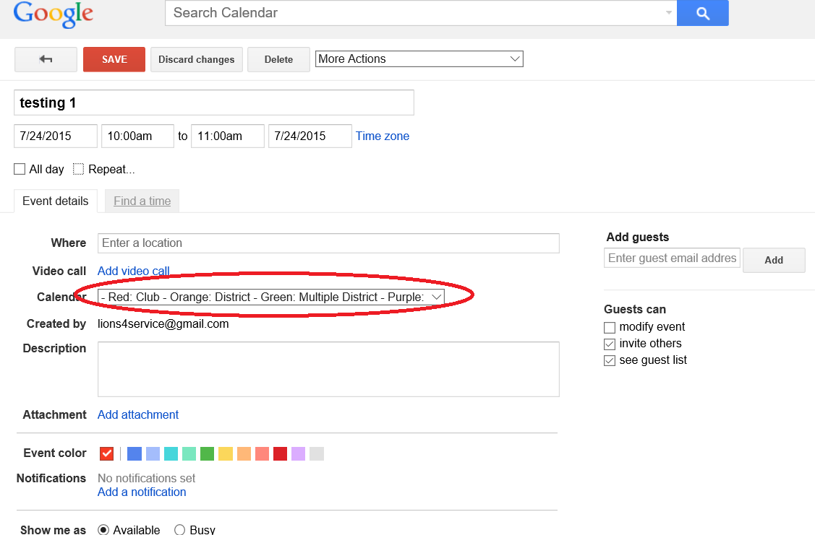

9. If you want to edit the detail about the meeting, click the column as below picture.
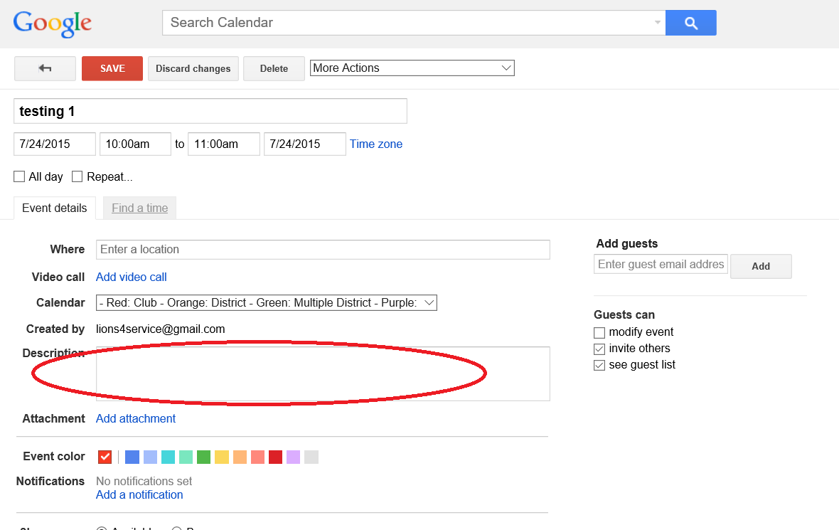
(Optional)
If you want to insert hyperlink on your description, here is an example code.
<a href="website-address">name</a>
1. Change website-address to your website address
2. Change name to a name you want to show.
Below is the example I use <a href="http://www.google.com.hk/">Google</a>
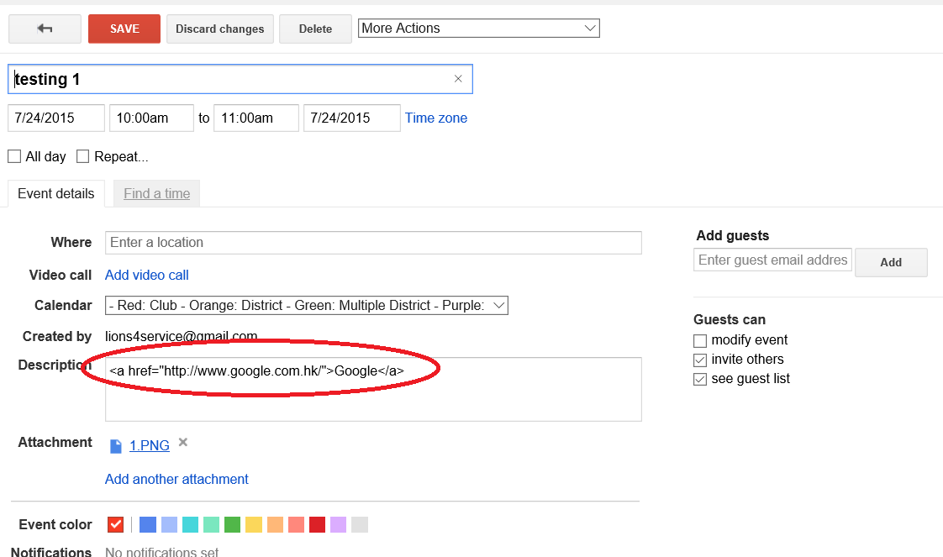
Here is what public can see in your description.
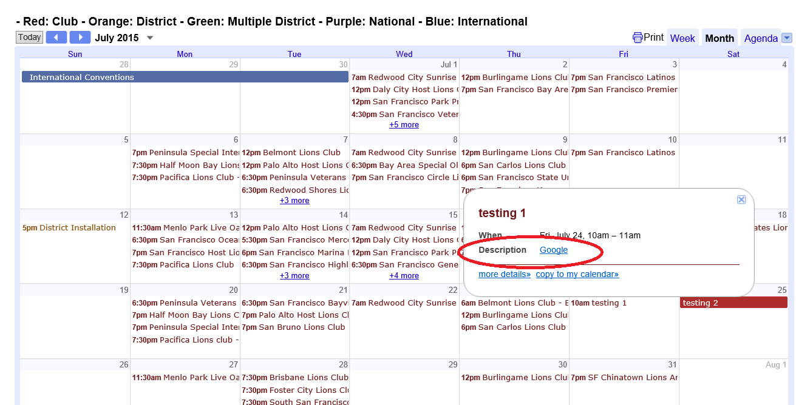

10. If you want to add more people to edit your club event, ENTER the person’s email, then select the guest permission. If you want they can edit the events, click “modify event”; otherwise unclick it. If you want they are allowed to invite others to see or edit (if the one you add is allowed to modify) the event, click “invite others”; otherwise, unclick it. After you finish the above selections, click “Add”. Once you save this event, the event will be automatically on their calendar. No invitation email will be sent to them. The guest is only able to see or edit this event only, so they are not allowed to modify other events on your calendar.
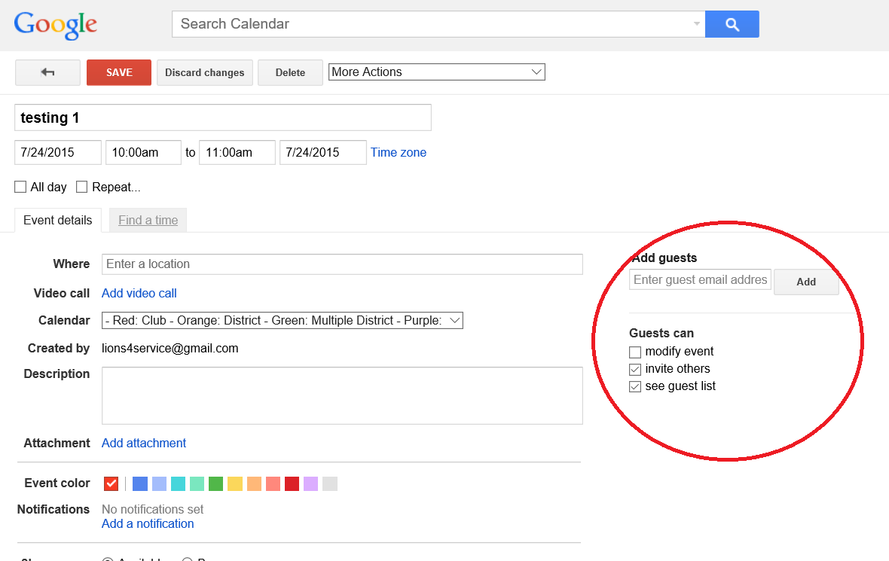
Here is what your guest can see or edit in the event.
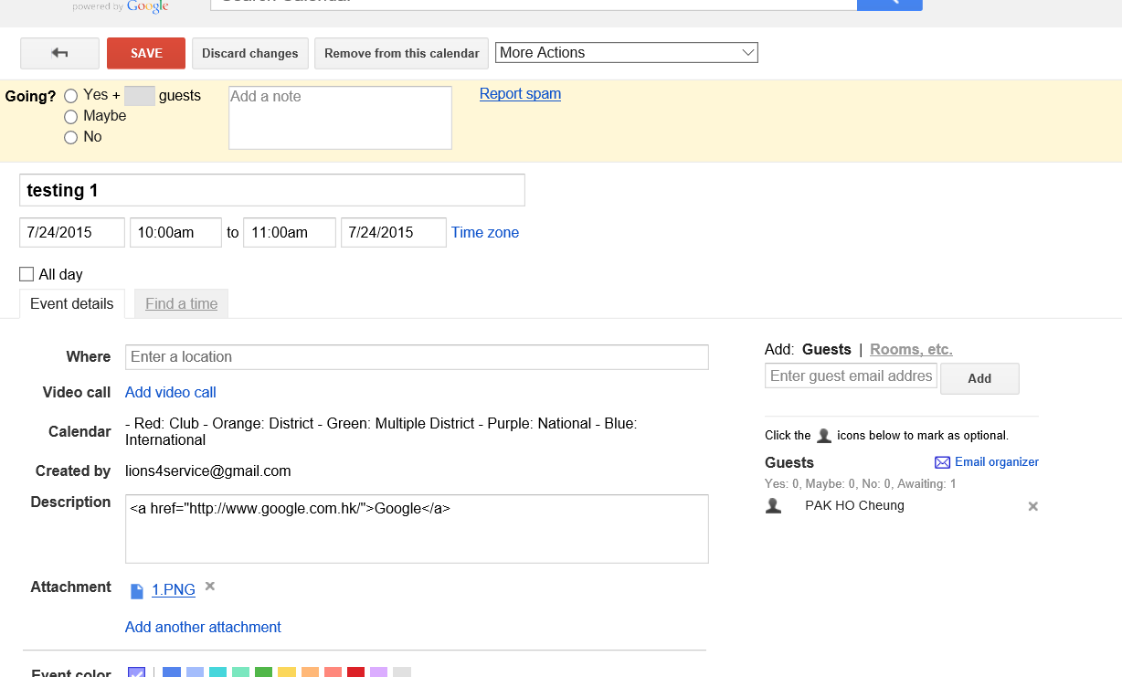
11. For attachment, it requires some works on Google Drive in order to make the attachment visible to public. But, our instruction also teach you what you need to do in Google Drive.
a) Click “Add attachment”.
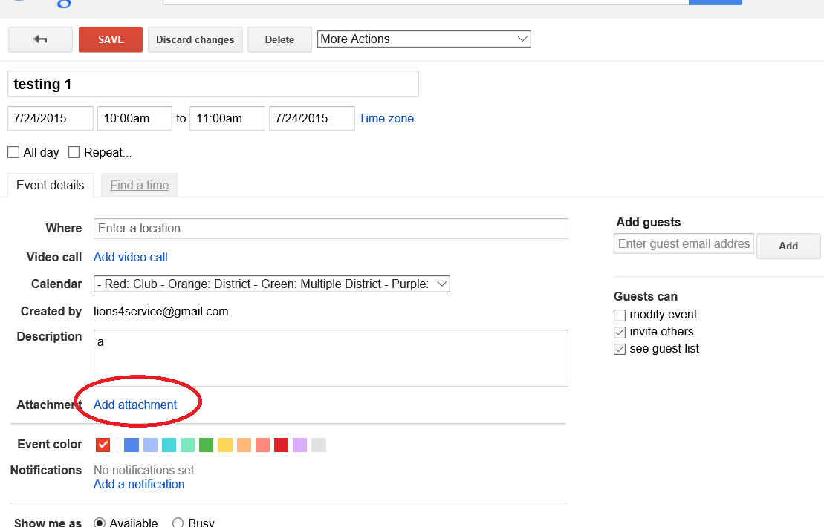

b) Click “Upload” then click “Select files from your computer”. After you select the document you want, click open. Then click “Upload”.
There is all you need to do in Google Calendar for now. You will need further work after you save this event.
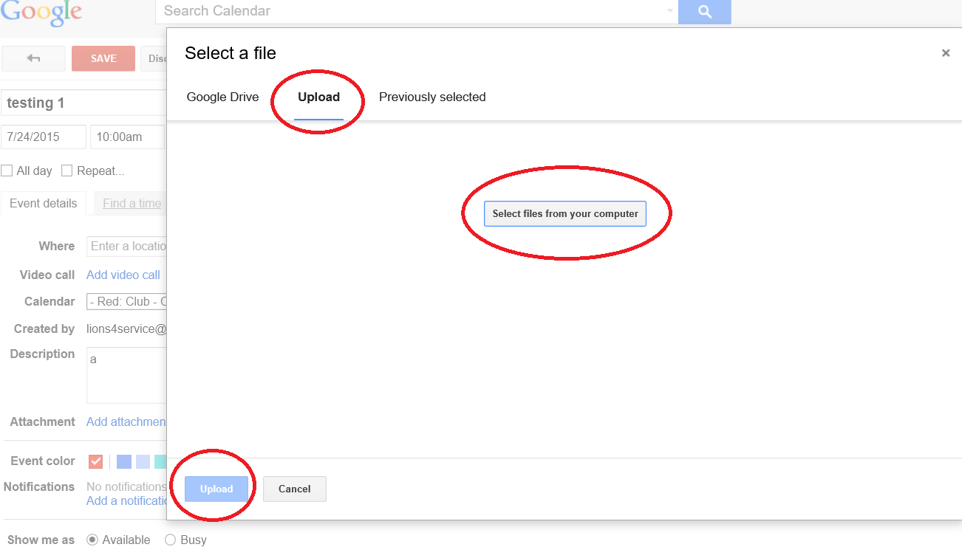
12. Please change the calendar’s visibility to “Public”.
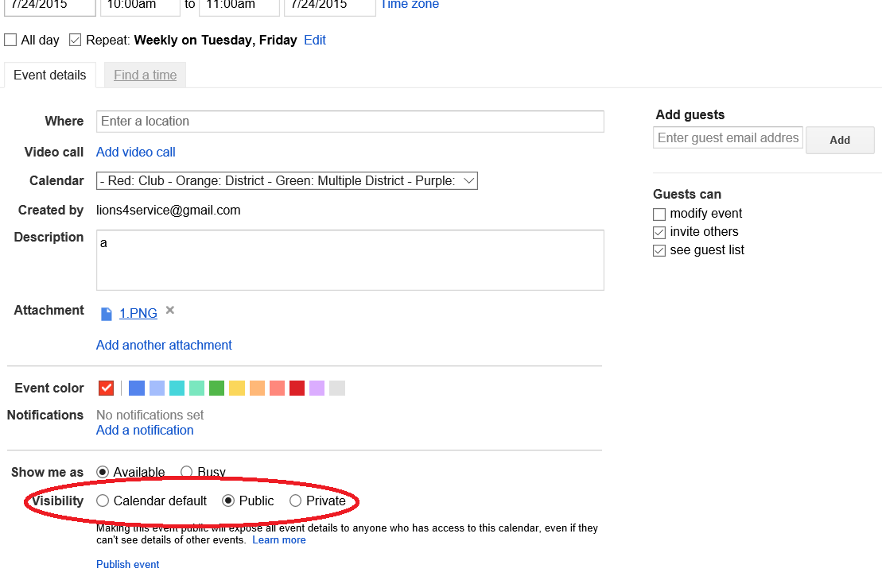

13. Once finish the edit of your club meeting, please remember to click “SAVE”!!
Then, select one of options you want.
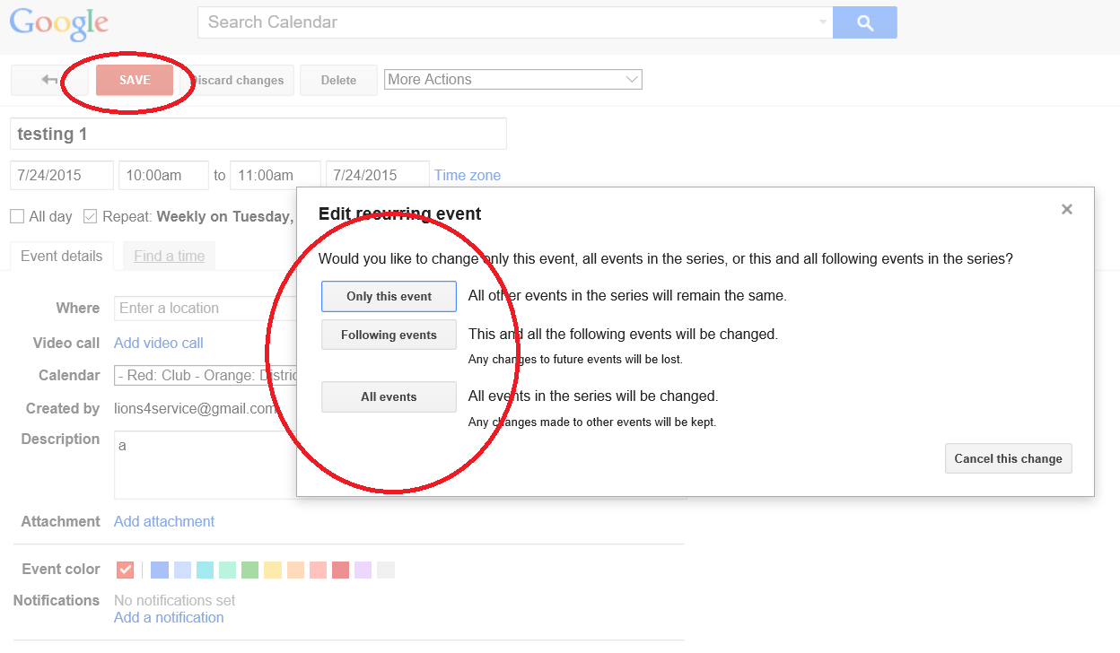

For people who do not attach an attachment, this is the end of the edit part.
For those who attach an attachment, go to next step.

14. Click the little box on the right top then click on Drive.
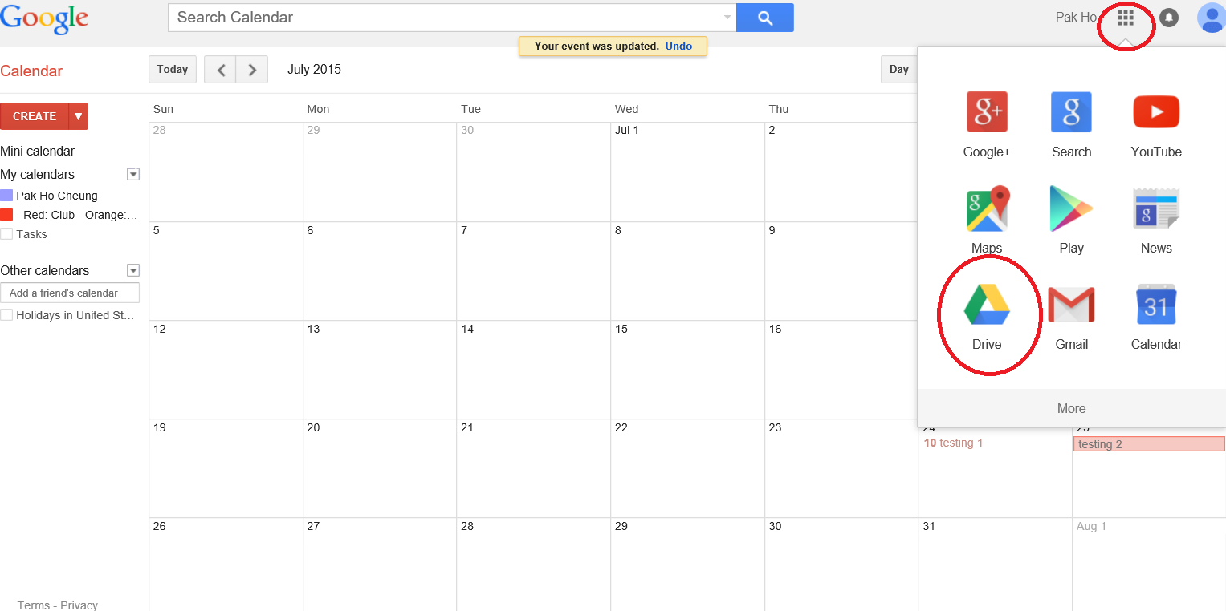

15. You are now on the Google Drive, and you should have 15GB free data for you to upload your club’s data. Right click the document you uploaded, and click “Share”.

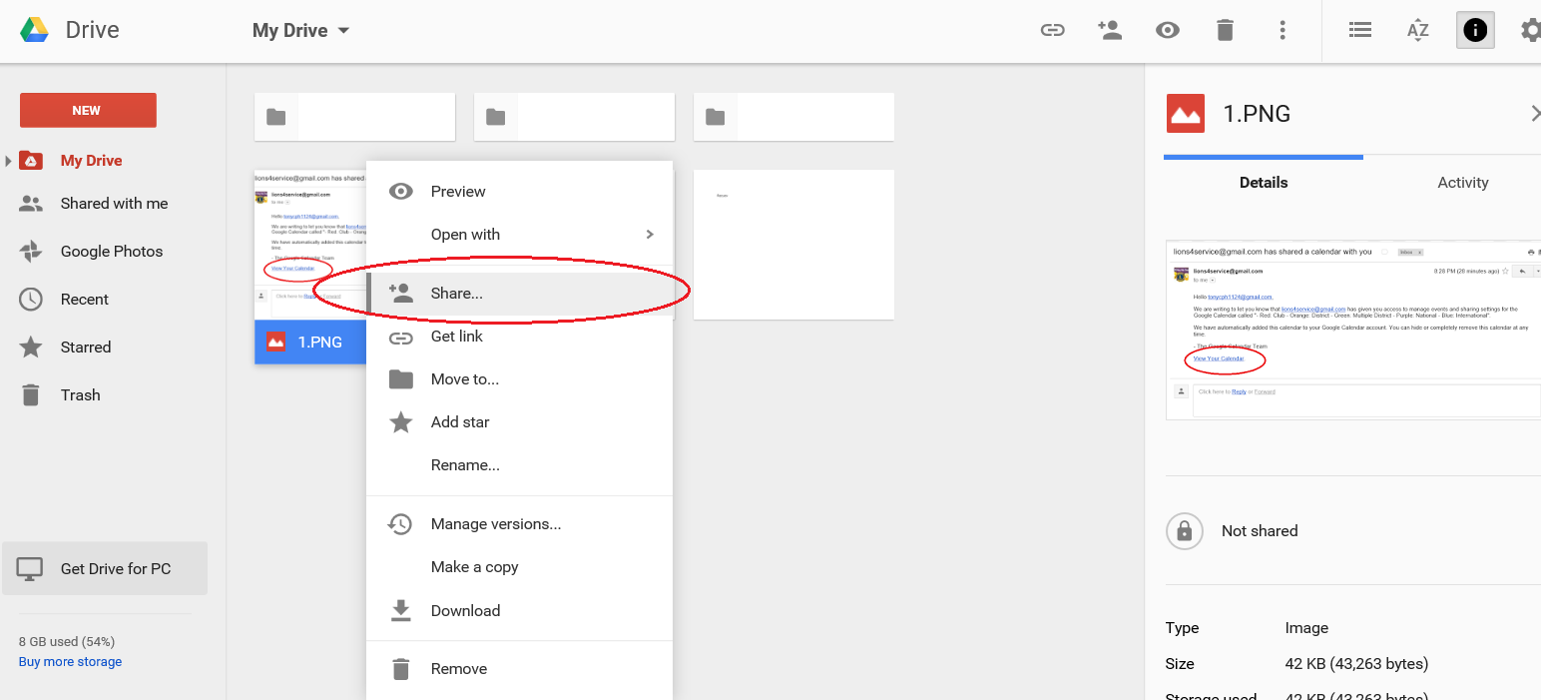

16. Click “Get shareable link”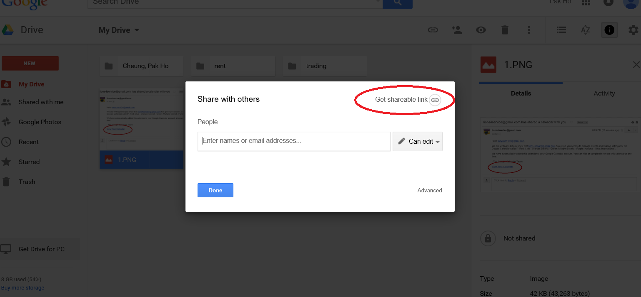

17. Click “Anyone with the link can view”.
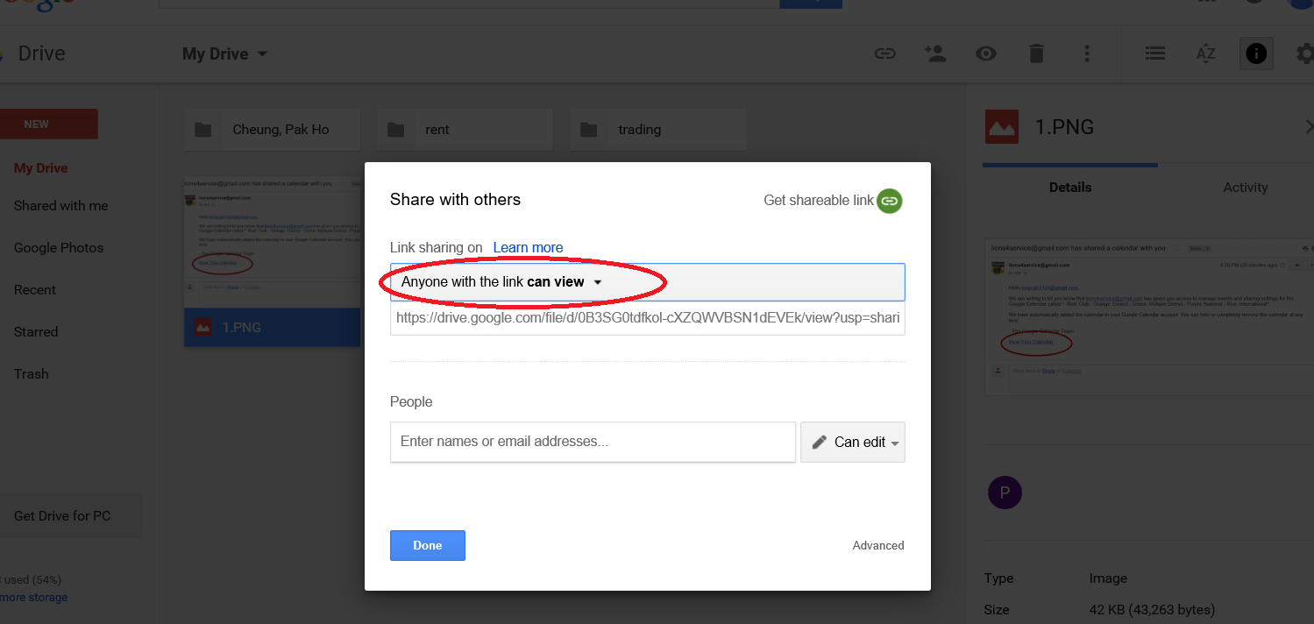
18. Change “Anyone with the link can view” to “More…”.
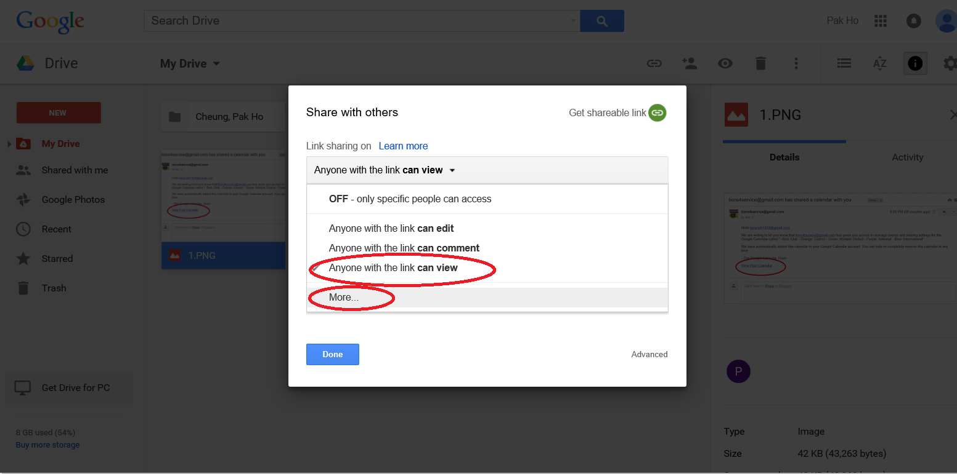
19. Change “On – Anyone with the link” to “On – Public on the web” Then click “Save”.
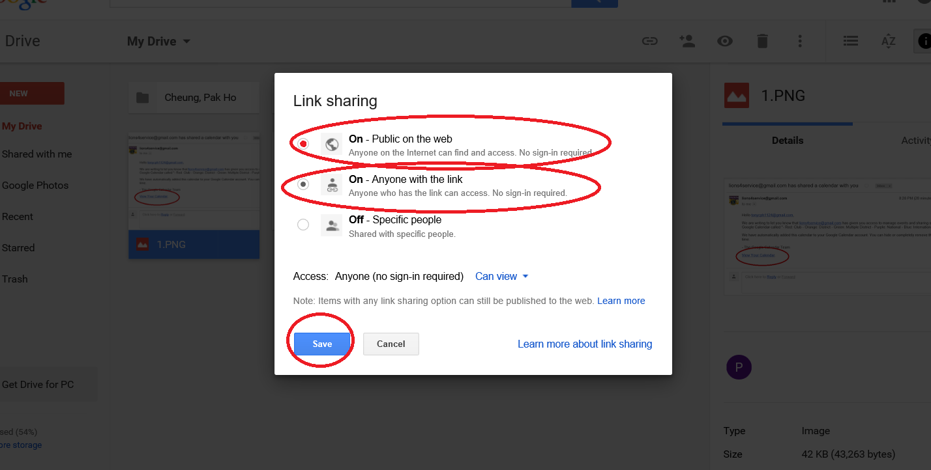

20. Then click “Done”.
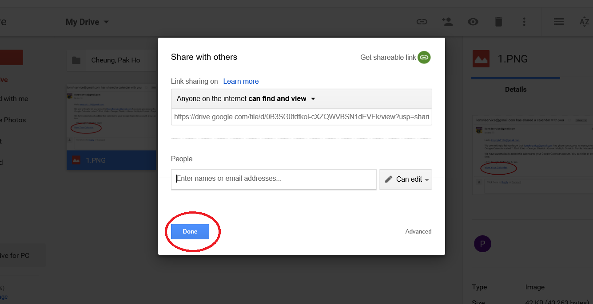

Now, you are successful to make your attachment visible to public.

Part III: Create a new event

1. Click the date you want create a new event. For example, if you want to create an event on July 7, 2015, click the space on July 7, 2015.
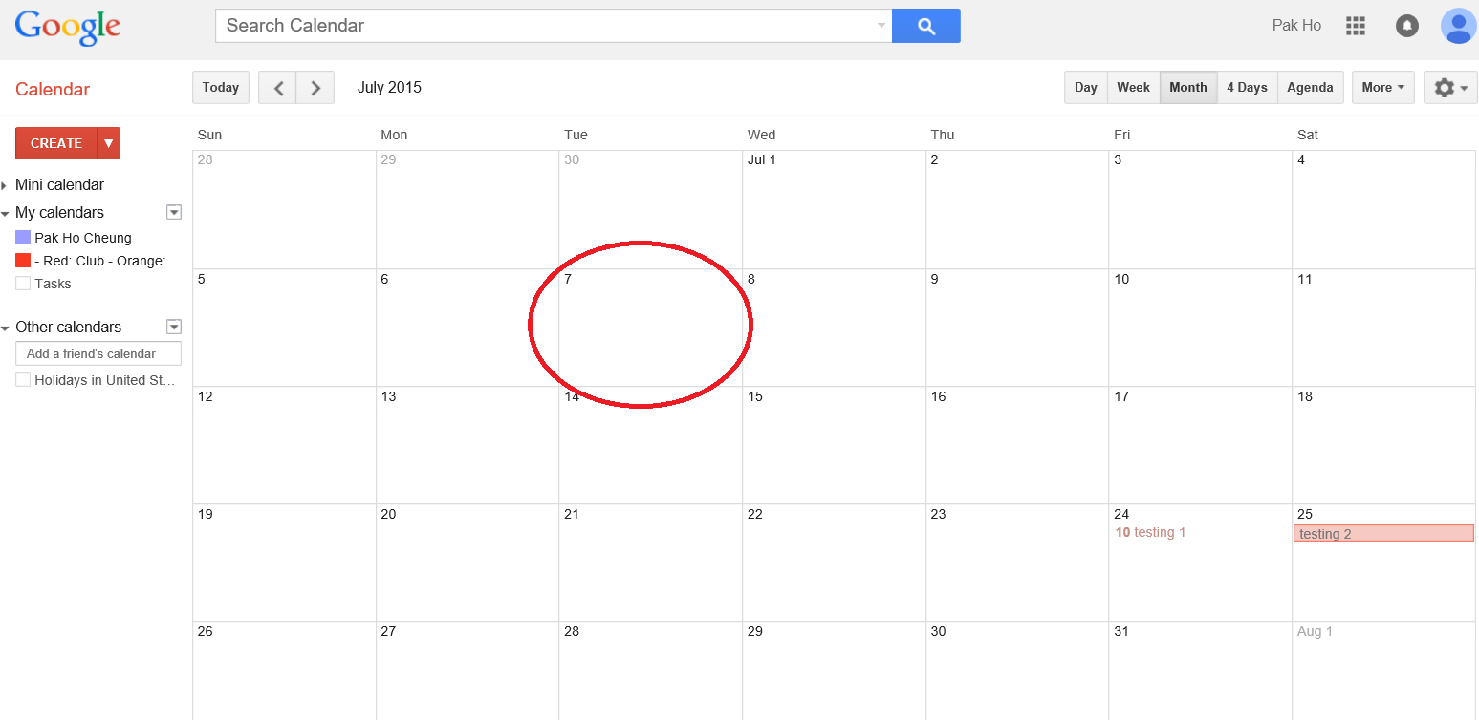

2. Click “Edit event”.
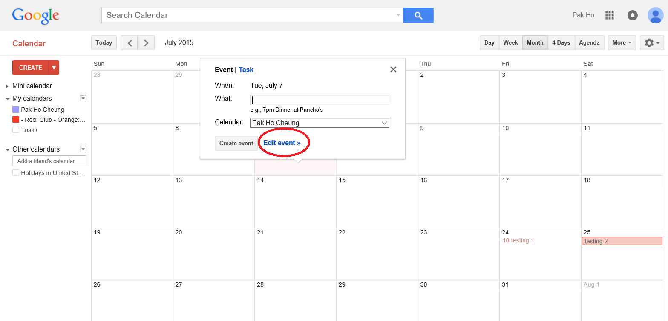

3. Then, follow Part II to edit your event.

Part IV: Delete an existing event
1. Click “delete”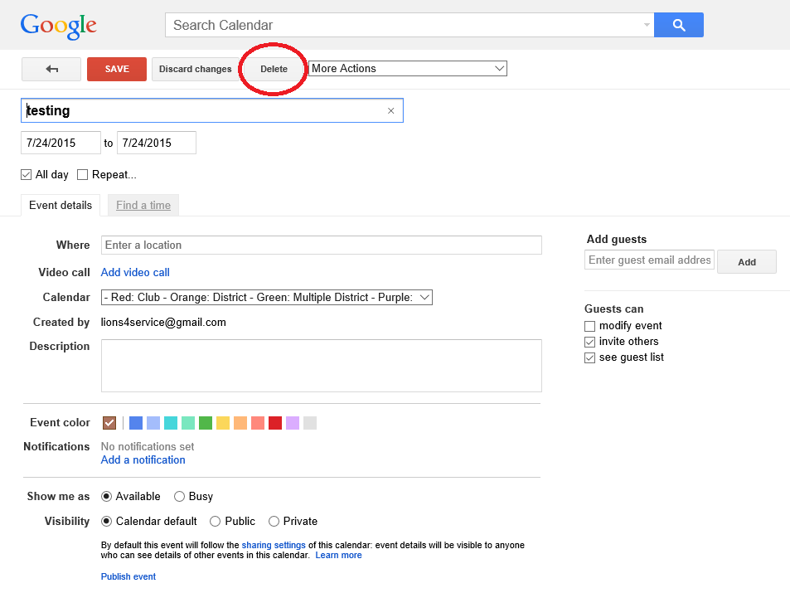
2. If you accidently delete the event, click “Undo” immediately.
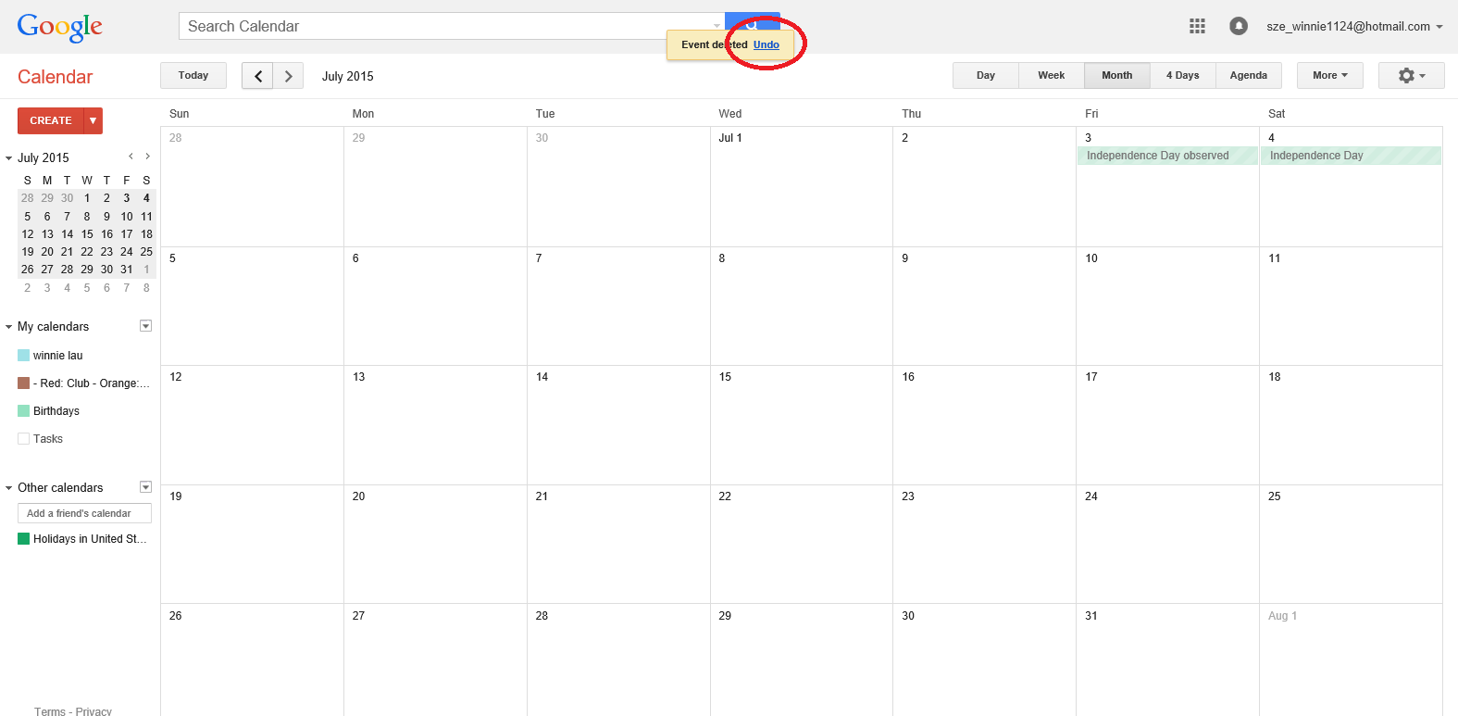

Part V: Next time you want to return to your calendar

1. Go to www.google.com
2. For old Google Account holder, skip this step.
For new Google Account holder, you will see something like below picture. By pass this, you have to register a Gmail address and “Submit”. If you don’t want to create one, just do the same thing as step 3.
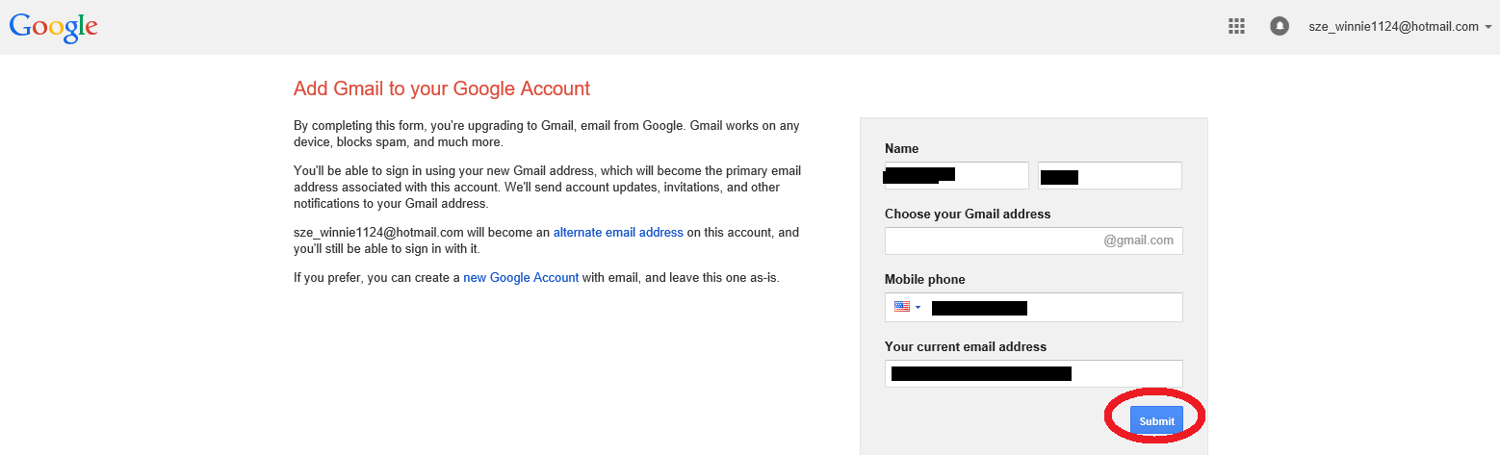
3. Click the square on the top right side, then click Calendar.
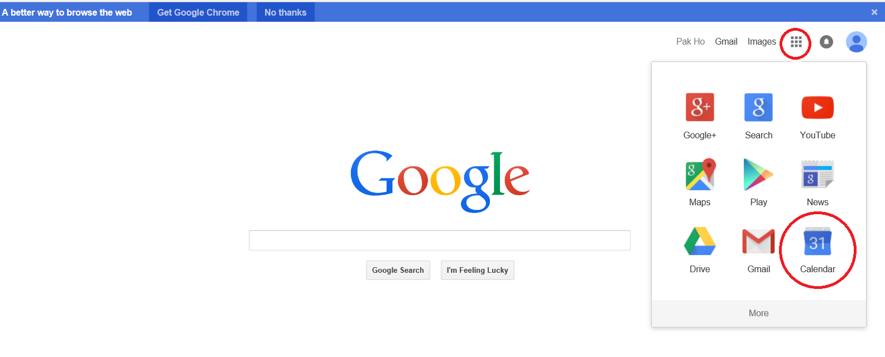

4. Click month on the top right side, which is circled in the below picture.
Part VI: Sharing your club’s calendar to others, so they can edit your complete calendar, not only on just 1 event
1. Click the downside arrow; then click “Share the calendar”.
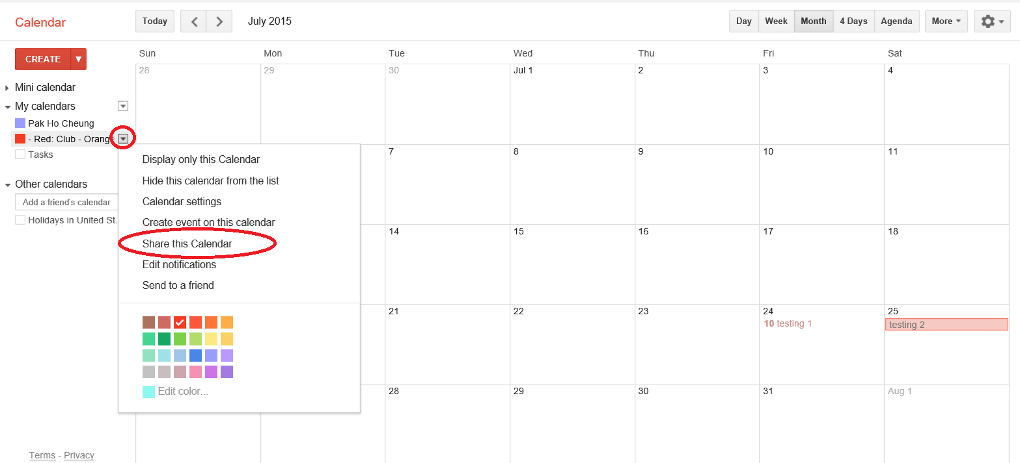
2. Enter their email address under “Person” (the email address has to be Gmail), then click the downside arrow.
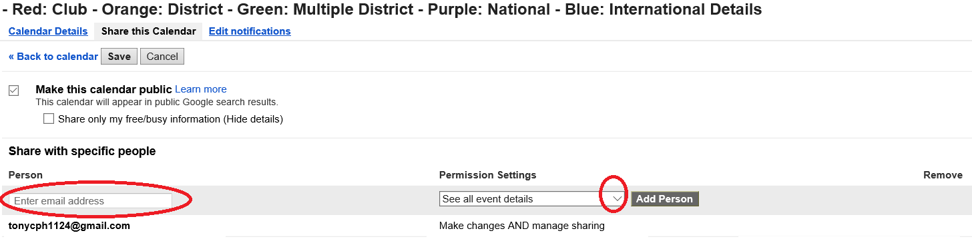
3. Select one of permissions to the person you want to add.
“Make changes AND manage sharing”:
- allow people to add or remove people and modify all events on this calendar
“Make changes to events”
- allow people to modify all events on this calendar only
“see all event details”
- all people to see your calendar only. No modify to the events is allowed.
“see only free/busy (hide details)”
- we prefer not select this option as we do not post any instruction on how to use free/busy feature on each event.
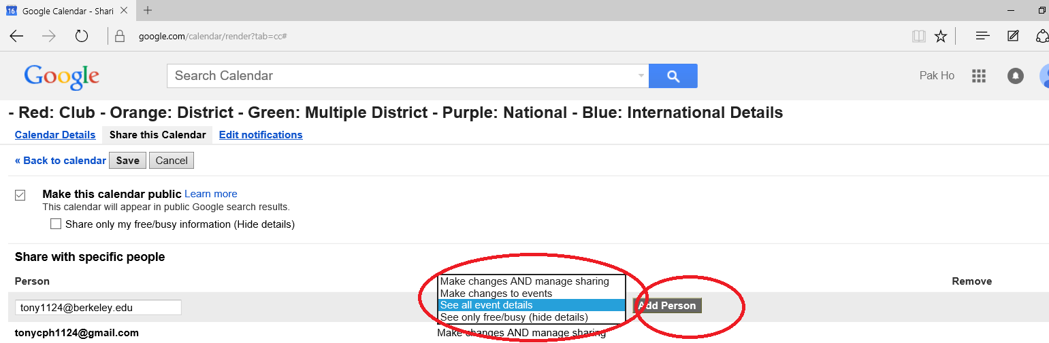
4. You will see the newest person you add is on the list. Click “Save” after you finish your adding. The person you add will get the same invitation email as yours.
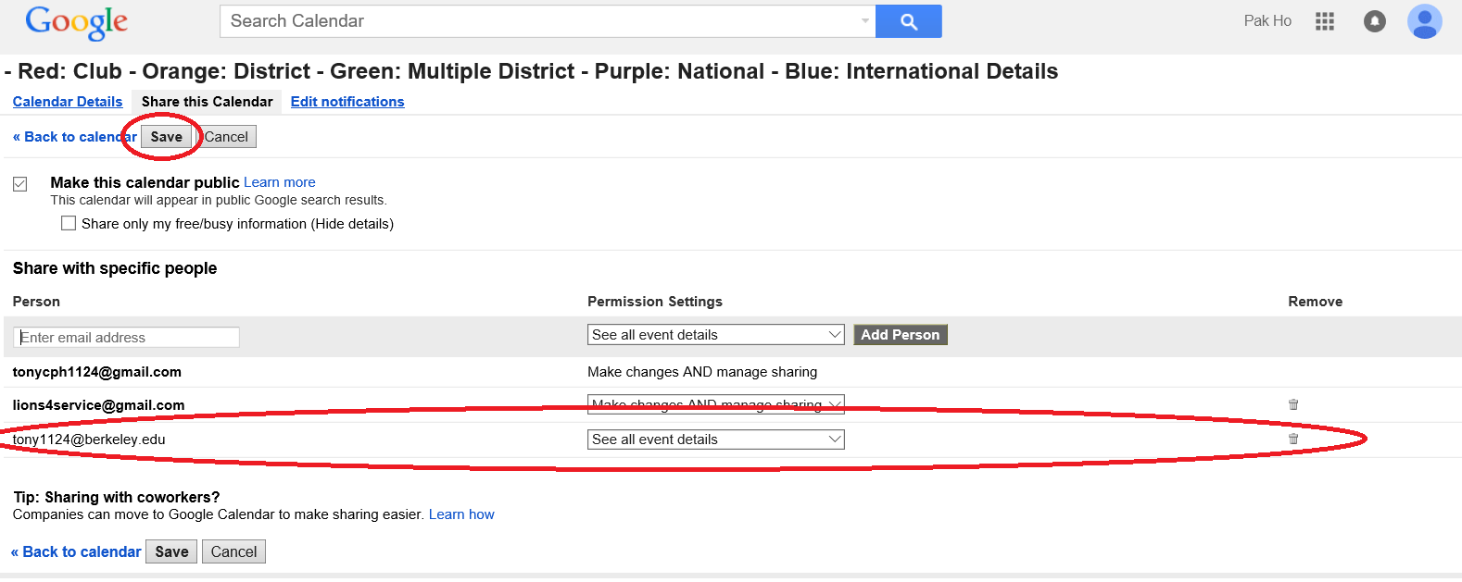
5. To stop sharing your calendar with a person, click the trash can sign, then “Save”
